# Administrative UI quick guide. Table of Contents.

Administrative UI quick guide. 1

Homepage 2

Working with grid 3

Companies 4

IPs list 5

Methods 5

Permissions 6

Search Columns 7

Search Groups 8

User Search Queries 8

Countries 9

Roles 9

Time Zones 9

Packages 9

Subscriptions 10

Subscription requests 10

Audits 11

Usage Statistics 11

Users 11

Informers 11

Resources 14

System Configuration 15

# Homepage

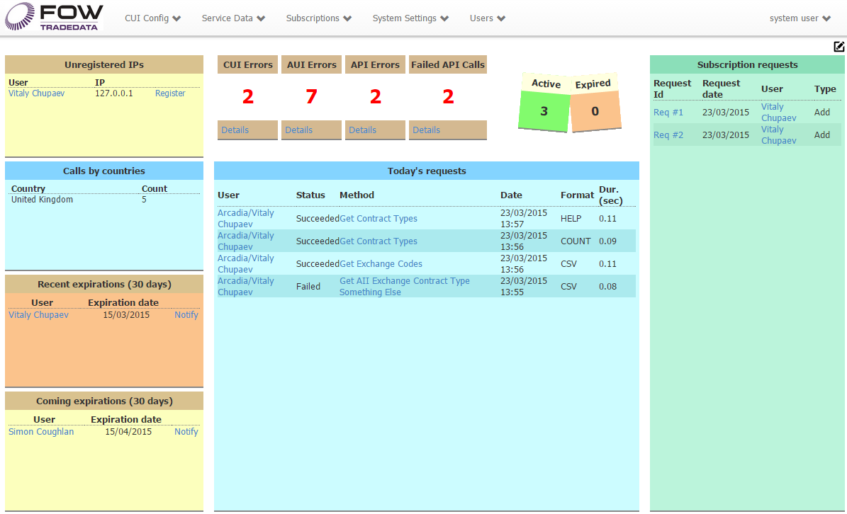

**Unregistered IPs**: When someone attempts to call a service method from the IP that is not yet allowed, the IP will be recorded and shown in this informer.

**Calls by countries**:Juststatistics.

**Recent expirations (30 days)**: List of the users whose accounts had expired during the last 30 days. When you click the “Notify” link,   
there will appear a new email window with some default text. This text comes from the Resources table,   
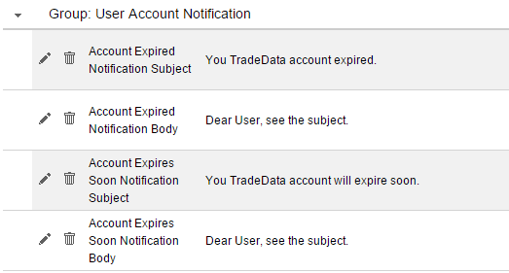

**Coming expirations (30 days)**: List of the users whose accounts will expire within next 30 days. Notification text is also taken from the Resources, see the Recent Expirations screenshot above.

**CUI Errors**: **C**ustomer **UI** – number of TODAY’s errors occurred on customer site, when click on Details, you will see ALL errors logged for the site.

**AUI Errors**: Administrative UI – same for administrative site.

**API Errors**: Same for the TradeData Service.  
  
**Failed API Calls**: stands for counter for failed calls, when for example user forgot to provide required parameter or credentials, or exceeded the hits limit, or has an expired account, etc. All exceptions of type WebFaultException are about incorrect usage or incorrect data in parameters.

**Active**: Number of active users.

**Expired**: Number of users whose account have expired or locked. Accounts can be locked after a certain number of failed attempts to log in. The number of attempts is defined on the Service Configuration page.

**Today’s requests**: List of requests to the service, including search requests on customer site (currently no limits for number of records, but can be changed in the stored procedure)

**Subscription requests**: List of requests from customer site to add or remove one or more packages. You can click on the request ID to open the Subscription Request page and approve/decline request. See the Subscription Request chapter for details.

Homepage has an edit mode, in which a user can rearrange the layout.

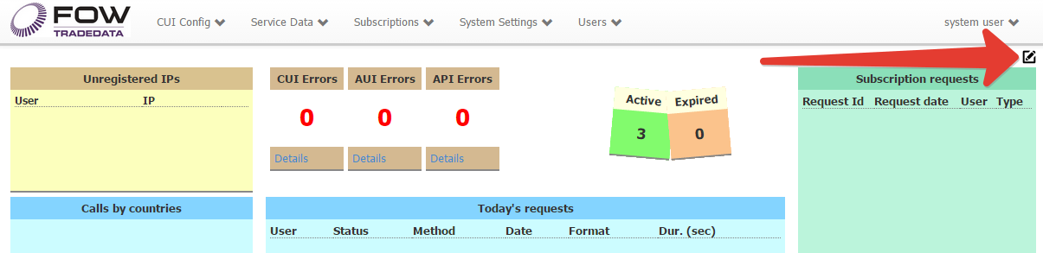

Informers have an absolute positioning on the page and in current version are not dockable.  
When you move informer there is an invisible grid with 5 pixels step to which the panel is snapped, this makes it easier to position panels on one line or one column.

Sometimes, after adding new informers their positions are not multiple of 5, this can be noticed when you are not able to place panels on one line. But after you save changes in edit mode and reload the page by F5, their positions will be recalculated to comply with multiplicity.

There are three buttons , Rearrange, Cancel, Save.

In case you have lost some informers after manually changing it position, you may want to use the Rearrange button, but it will only place informers in visible part of the page, so you can then change their positions. The result of rearrangement:

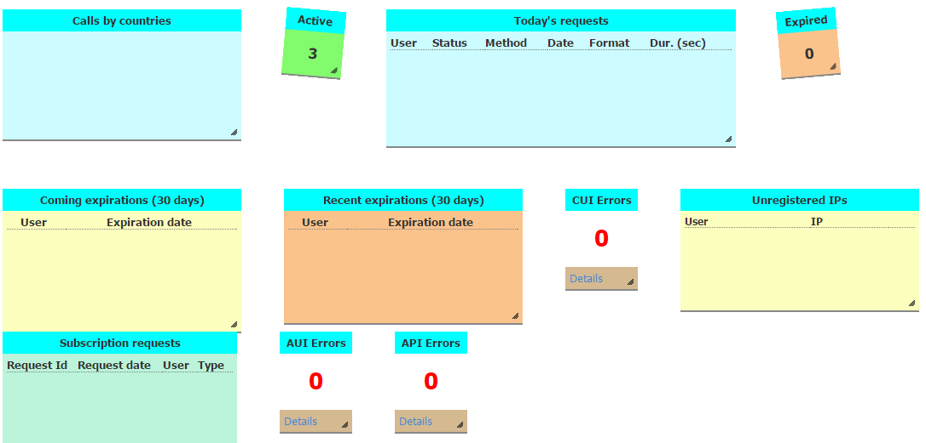

You can move informers by dragging the top panel, colored with cyan.  
To resize, drag the right bottom corner.

Any changes done in edit mode are not applied until you click the Save button, after that all changes will be stored in database.

Click Cancel to reject changes.

# Working with grid

1. Look & feel

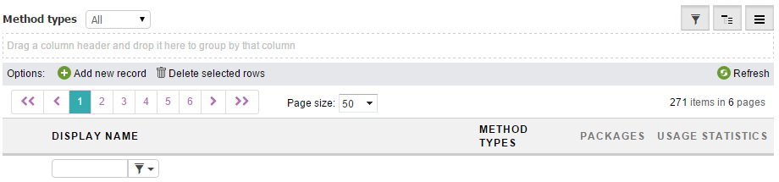

Grid allows records sorting, grouping and filtering.  
Not all columns allow doing that, if the column is a result of transformation or data formatting, the filters are not available, it is also not allowed to use sorting and grouping.

For cleaner look and feel, you can hide some of the options, this is a minimal set of controls:

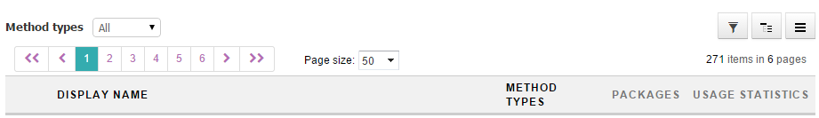

The pager appears automatically when necessary.

 Filter button, shows/hides the column.

 Group button, shows/hides the grid’s group panel.

 Command button, shows/hides the command panel, which contains Add, Delete, Refresh buttons.

The state of these three buttons and thus the state of grid panels is kept in cookies for each page separately, so next time you open the page, you will find it in the pretty same way you’ve left it.   
The page position is not kept.

2. Delete many rows

Click on row to select it, use may use Ctrl and Shift to select several rows or just press the left mouse button and move a mouse, then release the button.

You can now delete all selected rows.

# Companies

When adding company, you can choose the country; there is a list of IPs associated with the company and each IP also has the country.  
The country of IP is determined automatically via the lookup service, so even the company’s country is set to a particular value, the IP’s country may be different.

# IPs list

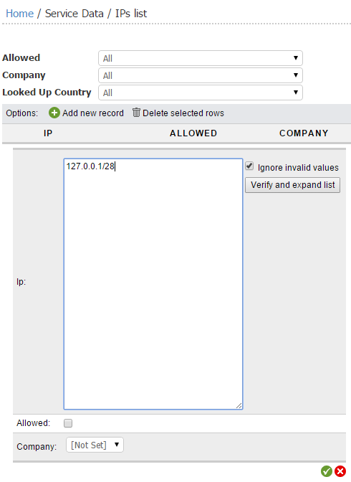Several IPs can be added at a time.  
You can add a list of IPs or use a CIDR notation as on screenshot.  
  
To see the final list of IPs that is ready to be saved, use the “Verify and Expand list” button. If “Ignore invalid values” is checked, all text that is not an IP will be removed, otherwise it will be marked as error, and you will be able to edit it:  
  
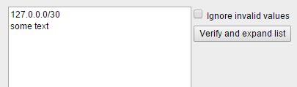

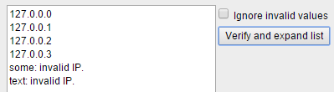

Since IP cannot contain a whitespace, it is treated as a divider.

It is also valid to use whitespace, comma, semicolon, new line.  
Duplicates will be removed.

|  |  |  |
| --- | --- | --- |
|  | -> |  |

You can do all these changes in both edit and insert modes.  
  
When you insert/update IP the lookup service will be started to determine the country the IP belongs to.  
This is an asynchronous operation, which depends on outer service, so the country may be updated a bit later after you have saved your changes.  
  
The IP country is also verified each time user calls one of the service methods, but the lookup is performed only if country field is empty in the database.   
  
If for some reason you need to update the country, it can be done in edit mode.

# Methods

There are three types of methods.

**1. Virtual**, it represents the alias for some interaction with the service, which does not really have a corresponding stored procedure, for the moment the only virtual method is Get By Symbol, which stands for search.

**2. Informers**, these methods are used to fill informers with data.  
  
**3. Data**, the methods, which are the subject of trading.  
  
Methods are the aliases for stored procedures and cannot have an arbitrary Name.  
Usually the name like GetCFIUnderlyingAsset will be translated to spTDAppSelectCFIUnderlyingAsset.

The Display Name is free for changes.

Methods cannot be included into subscription by themselves, to do this the Package should be created.

# Permissions

Currently permissions are used to configure search output.  
Using Search Groups, Roles and Permissions it is possible to restrict for users to view content of the field in search results.

The column content is available if   
 - the column is included in the Search Group and a User has same permission(s) as the Search Group requires  
 - the Search Group doesn’t require any permissions  
 - the column is not in any of Search Groups

The column content is restricted if  
 - the column is included into the Search Group and the group requires permissions which are not assigned to a User.

There is no way to restrict for a particular user, but there is a way to allow for a particular user.

So to restrict content for all users, create a new Permission, choose Search Group, set Permission type to “Search Groups” and save it.

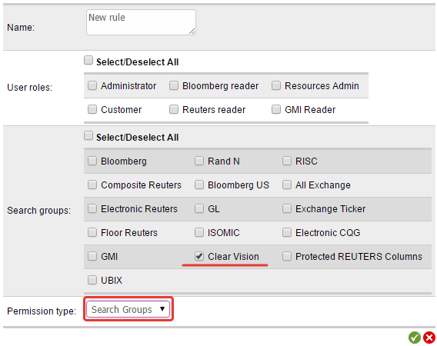

Now users will see search results like this:

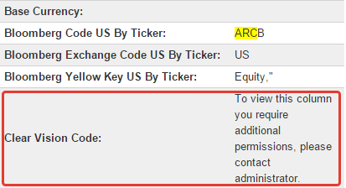  
  
To allow a particular user to view the content, create a new Role, or edit existed – choose user, choose permission(s), save:  
  
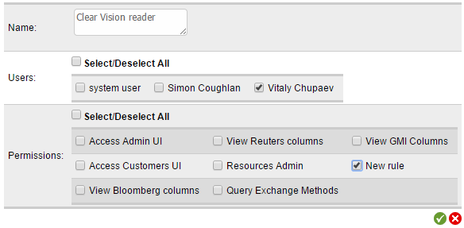

It’s now allowed:

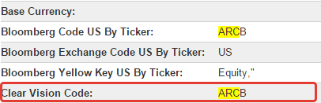

# Search Columns

Search Columns are used in Search Groups.  
The default list contains columns from XymRootLevelGLOBAL and XymREUTERSTradedSeriesGLOBAL tables.

The search is performed only by Search Columns included in Search Groups, even the output contains much more.

# Search Groups

Search Groups are used to define columns to search by and to limit access to the columns content in the search results, both for UI and API.  
Search groups exist for two tables which are used for search.

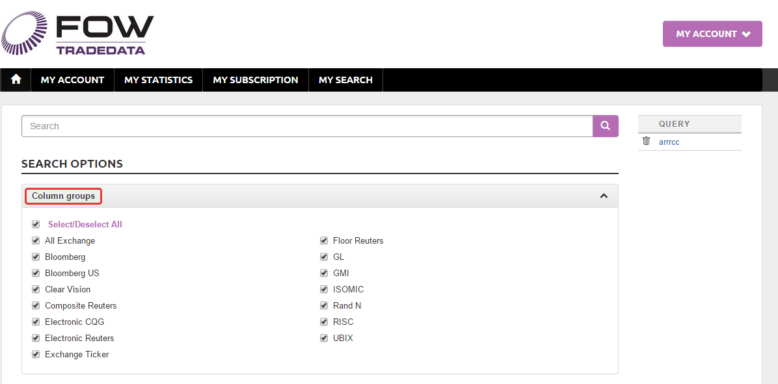

Note that two tables may contain columns with the same name, but they are different columns, for example, to restrict the ACN column in both tables, create two Search Groups, one per table and set permissions for each of them. If the column is restricted in one table, the column with the same name in the other table is still allowed.

The search is performed only by Search Columns included in Search Groups, if a Search Group has a required permission, the search is done by the column, but content is replaced with message:



# User Search Queries

Here the users’ stored search queries could be found.  
This is a consumer entity and shown here just like that.  
It is possible to deleted the query, but not possible to edit or insert.

# Countries

Just countries.

# Roles

Roles define users’s capabilities.  
There are several predefined roles: Administrator, Customer.

Administrator role has a set of built-in permissions and allows access to Admin UI.  
Customer is created as an example, it doesn’t grant access to customers site.  
Any active (database term, not universal, IsActive = true) user who is authenticated and has passed the IP check can use the customer site.

# Time Zones

For the moment, the time zone assigned to user is used to convert UTC time to local on both sites.

# Packages

This is a number of methods, access to which are sold entirely.  
User buys the package and can query included methods via the service.  
If “Free for All” option is checked, those methods will be available for all users.  
Currently this is done to support the search, as it requires access to a number of methods, they are listed in the “API Search support” package.

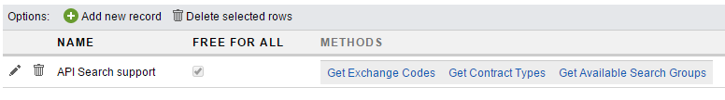  
Packages except free ones, are listed on the Customer site on My Subscription page.  
Free packages are not shown.

ADMIN UI:

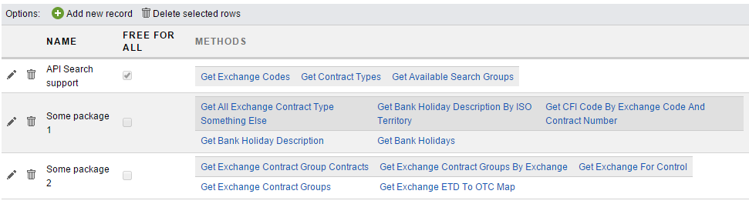

CUSTOMER UI:

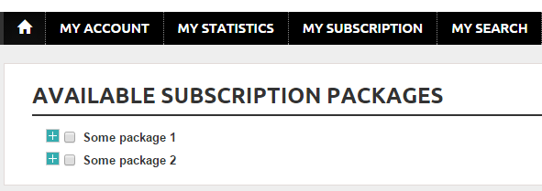

# Subscriptions

Subscription defines the packages the user subscribed for.

# Subscription requests

Subscription request is used to automate the process, a user can choose the package he wants to subscribe/unsubscribe and send a request.  
Administrator then has ability to accept/decline the request, there is an ability to add comment, when accepting/declining, it will be visible for user.  
The acceptor name is also visible for user.

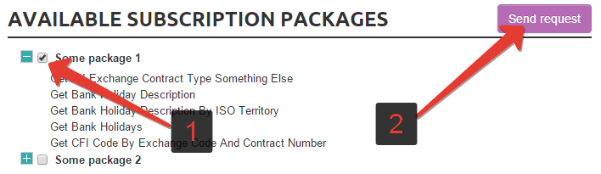

After requests is sent, the package is not available for other actions, until Administrator marks request as fulfilled.

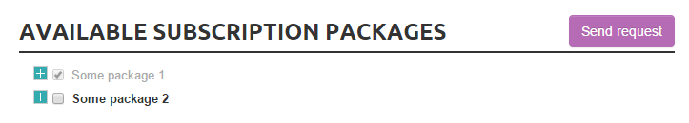

There will be an email notification sent about request and informer will show the new request

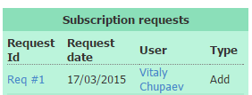

# Audits

Shows actions performed by users, especially by administrators – what entities were modified/added/deleted, who logged in.  
For customers it only contain information about logins.

It won’t be comfortable to work with audit data when it is too much.  
While navigation is quick as it loads only current page, the grouping, sorting and filtering require all data to be loaded.

If you think you do not need this data anymore in UI you can mark as deleted in db.   
It is possible in the way delete from Audits or update Audits set IsDeleted = 1 result is the same, but in the first case the trigger will do the work for you.

Data will stay in database, but anything marked as IsDeleted, won’t be loaded to the client.

# Usage Statistics

Shows history of method calls, this is especially to monitor customers activity.

It won’t be comfortable to work with audit data when it is too much.  
While navigation is quick as it loads only current page, the grouping, sorting and filtering require all data to be loaded.

If you think you do not need this data anymore in UI you can mark as deleted in db.   
It is possible in the way delete from UsageStats or update UsageStats set IsDeleted = 1 result is the same, but in the first case the trigger will do the work for you.

Data will stay in database, but anything marked as IsDeleted, won’t be loaded to the client.

# Users

When adding new user, one should specify a several fields, which require some explanation.  
Each user has Threshold period which could be Day, Week, Fortnight, Month, Year.  
When creating a user, the initial Threshold Period End must be specified – the date, when the current period will end up, then it will be automatically updated by daily job. If this field is set to past, user won’t be able to call methods until next job run, if the period is set far in the future, the real period type will be ignored until the date is passed. For example if period is set to Day, and End of period for the month ahead, the job will not update this account for a month.

When you want to deactivate user, if you set account expiration date to the past, the user will be deactivated only on next run of the job.  
Do deactivate immediately, set the **Is Active** to False.

# Informers

Informers are used to keep administrator aware about different events of the system, each informer is described in the Homepage section of this document.

Here is a more technical description and examples of how they could be changed.  
Informers are the panels which display information that came from database. Data is converted to XML and transformed with XSLT to desired formatting.

By default, all available informers are already added for the system user.

Informers are personal, so that each user has its own set of instances, the best way to create informers set for a user is to log in with this user and clone informers, cloned informers will be assigned to the current user.

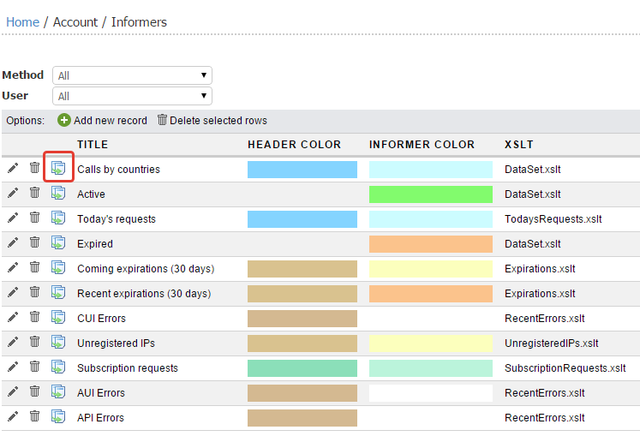

Informers decoration is based on CSS. They have base classes, but you can specify the style in informers settings:

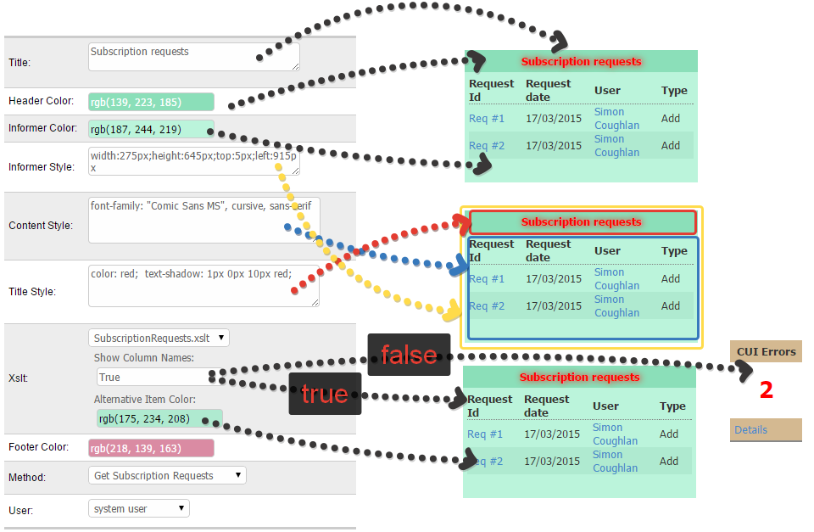

For the informer with new data set, in the Users DB there should be created a stored procedure with **spInformer** prefix.

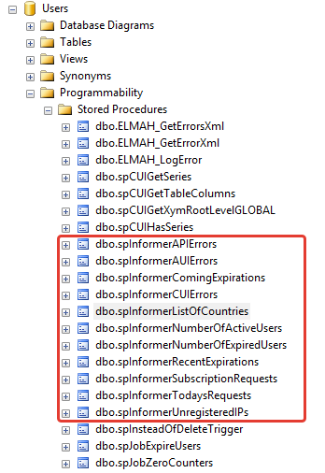

Then it should be registered in Methods via the Admin UI with ‘Informer’ type.

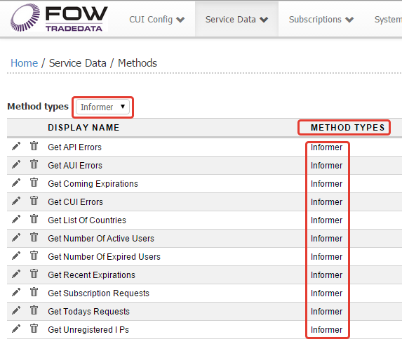

Then you can create a new Informer and choose this method as data source.  
For default formatting you can use the DataSet.xslt, which just creates a HTML table to reflect the dataset.

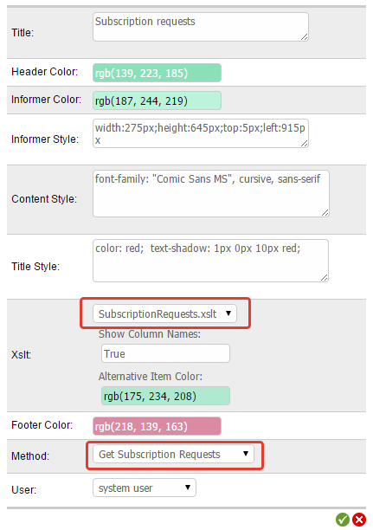

For specific formatting create new xslt file and place it to \stash\tdapi\src\UsersUI\UsersUI\Content\Xslt\Informers.

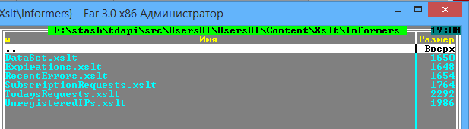

# Resources

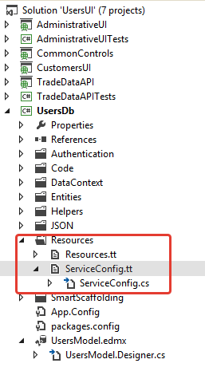There is a number of messages that are shown to users or other text used on sites and/or in service.  
New resource cannot be added just via the Admin UI, it should be also used somewhere in the code.  
For that reason the deletion is not allowed. Once the resource is added, you can update Value, Description and Group name fields under administrator account.  
  
If you are going to recompile the site and need to manage resources, add Resource Admin permission to your account, this will allow a full set of operations.

All resources are kept in the application cache, so if something was changed the application must be restarted or changes will take effect after cache expiration, the default timeout is defined in the “Service Configurations” table – “Cache Expiration Timeout” and set to 240 minutes. Cache doesn’t have sliding expiration, so 4 hours is the maximum period to wait.

If text contains placeholders like {0} or {1} they all must be kept to avoid exceptions.

When new resource added the code should be recompiled. To use new value go to the T4 template Resources.tt, just open it and save (no need to change anything), on save the template will regenerate accessors and you will be able to use your value in the following way: Resources.My_New_Value.

When giving a name for the new resource, take into account that all whitespaces will be converted to underscores.

All resources have description with explanation where they are used.

# System Configuration

It is very much like Resources, but values here are used to configure sites and service.  
Settings are shared, that mean that they could be used on both sites and in service.

There is its own T4 template – ServiceConfig.tt, see the screen shot in the Resources chapter.

All Service Configuration records are kept in the application cache, so if something was changed the application must be restarted or changes will take effect after cache expiration, the default timeout is defined in the “Service Configurations” table – “Cache Expiration Timeout” and set to 240 minutes. Cache doesn’t have sliding expiration, so 4 hours is the maximum period to wait.